Course Name | Test
Objective | Test
Version | V1
Owner | Tester
Date | 15/09/2020

Topic Title | Page/Slide Number | Media | Developer Notes | On Screen Text | Narration Text
Welcome | 1 | 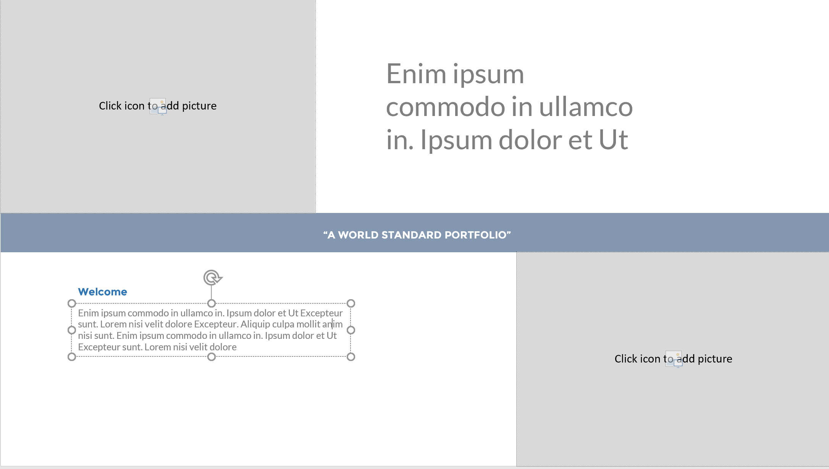  Image 1 – top left  Image 2 – bottom right | Media # 111111  Image 1 source:  Image 2 source: | Top right:  Enim ipsum commodo in ullamco in. Ipsum dolor et Ut  Mid: “A WORLD STANDARD PORTFOLIO”  Bottom left:  Enim ipsum commodo in ullamco in. Ipsum dolor et Ut Excepteur sunt. Lorem nisi velit dolore Excepteur. Aliquip culpa mollit anim nisi sunt. | Enim ipsum commodo in ullamco in. Ipsum dolor et Ut
Objective
Introduction
Topic
Knowledge check
Summary
Exit

